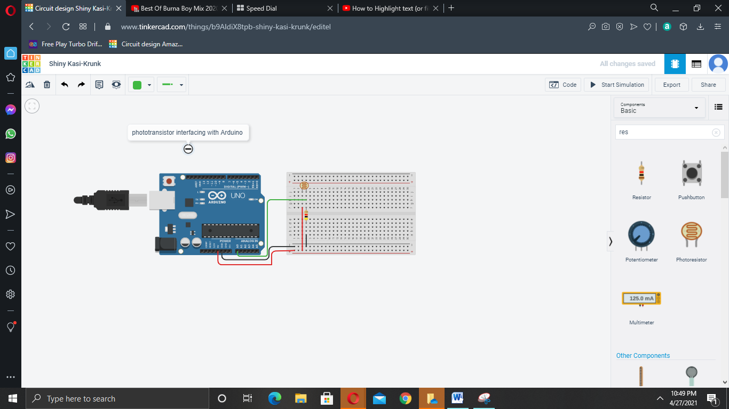

void setup ()

{

pinMode(A0,INPUT)

Serial.begin(9600);

}

void loop()

{

int A=analogRead(A0);

Serial.print("Sensed light is ");

Serial.println(A);

delay(1000);

}